CSCE 567 Final Visualization Project Proposal

Name: Maximus Fernandez

Project Purpose:
e.g. the purpose of this project is to explain/inform/convince … to/about/of …
The purpose of this project is to inform and persuade people interested in the gaming industry that the rise of live-streaming platforms, specifically Twitch, did not merely reflect existing video game popularity, but it actually took a role in creating them.

My hope is to use visualizations to demonstrate that Twitch viewership spikes consistently preceded Steam player count surges across four landmark case study games (Among Us, Vampire Survivors, Fall Guys, and Lethal Company), arguing that streamers manufactured mainstream awareness for titles that were previously unknown to general audiences.

I. Introduction / Background
brief overview of the topic of interest – 1 or 2 paragraphs
The relationship between streaming platforms (Twitch, YouTube, etc.) and video game popularity has fundamentally changed how games are able to reach mainstream audiences. Before the rise of Twitch, many games would need to rely on traditional marketing, coverage from the press, and word of mouth to build a larger player base. For many small indie game developers with no marketing budget, there was difficulty in reaching beyond a niche audience, regardless of the game’s quality. This dynamic shifted around 2013 with the growth of live-streaming culture, and by 2020 had completely transformed.

Many games in recent years have demonstrated a striking pattern where a title sits in near-total obscurity for months or maybe even years, until a popular live streamer (or multiple streamers) begins playing it on Twitch. As a result, viewership explodes overnight, and Steam concurrent player counts follows within days to weeks. The objective of this project is to visualize this same pattern across all case study games, examining the timing between Twitch viewership peaks and Steam player count peaks to build a data-driven argument for causation rather than mere correlation.

II. Audience
describe the target audience for your visualization project
The audience is college-aged gamers and streaming viewers who are familiar with the games in the case studies but may not have considered the data behind the cultural moments they experience.

It may also interest game developers and marketing professionals interested in understanding the commercial dynamics of live streaming exposure.

III. Dataset(s)
Source 1: Twitch Tracker – monthly Twitch viewership stats
- Among Us: https://twitchtracker.com/games/510218
- Vampire Survivors: https://twitchtracker.com/games/1833694612
- Fall Guys: https://twitchtracker.com/games/512980
- Lethal Company: https://twitchtracker.com/games/2085980140

Size: 90-100 monthly records per game
Attributes: month, average viewers, peak viewers, average streams, peak streams, and hours watched.
Data issues: Twitch tracker doesn’t offer direct CSV export, so I’m going to manually put their monthly statistics data into a table then clean it up. Some early months also show near-zero or missing values for games due to insignificant Twitch presence (symbolized by an em-dash).

Source 2: Steam DB -- concurrent player counts
- Among Us: https://steamdb.info/app/945360/charts/
- Vampire Survivors: https://steamdb.info/app/1794680/charts/
- Fall Guys: https://steamdb.info/app/1097150/charts/
- Lethal Company: https://steamdb.info/app/1966720/charts/

Size: 2000-4000 records per game at 10-minute intervals from each game’s Steam launch date until the present
Attributes: datetime, peak players, average players
Data issues: Steam player data is recorded at 10-minute intervals while Twitch Tracker data is monthly, so I would need to find monthly averages and peaks before the two sources can be joined together.

Source 3: Google Trends – interest over time (just capturing around the time of their peaks)
- Among Us (Jan 2019 – Dec 2021): https://trends.google.com/explore?q=%2Fg%2F11fmxtkfkz&date=2019-01-01%202021-12-01&geo=Worldwide
- Fall Guys (Jun 2020 – Dec 2021): https://trends.google.com/explore?q=%2Fg%2F11hyjkpzj9&date=2020-06-01%202021-12-01&geo=Worldwide
- Vampire Survivors (Jun 2021 – Dec 2023): https://trends.google.com/explore?q=%2Fg%2F11pdr9rnbf&date=2021-06-01%202023-12-01&geo=Worldwide
- Lethal Company (Aug 2023 – Mar 2026): https://trends.google.com/explore?q=%2Fg%2F11t4j11m32&date=2023-08-01%202026-03-01&geo=Worldwide

Size: 30-40 monthly records per game
Attributes: month, interest score
Data issues: Interest scores on Google Trends are relative, not absolute, so raw scores are not directly comparable across games and will be used to identify the timing of public awareness spikes rather than to compare magnitude across titles.

My plan is to assemble a dataset from these three sources. They will be cleaned and aggregated to monthly granularity. This should produce a dataset of ~250 records and 8 attributes using the pandas library in Python before loading into a data visualization tool.

IV. Proposed Visualizations
Visualization #1: Multi Axis Line Chart
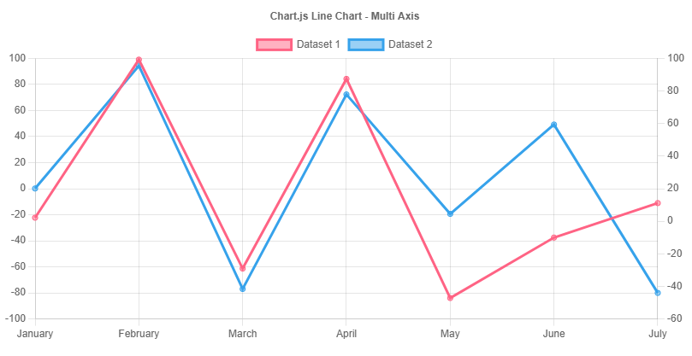
Image from https://www.chartjs.org/docs/latest/samples/line/multi-axis.html

Description: A dual-axis line chart for each of the four case study games, showing Twitch peak viewership on the left axis and Steam concurrent players on the right axis over time. Maybe a third dashed line will show Google Trends interest score as a secondary signal of public awareness.

Interactive Elements:
- Game selector filter to switch between each case study
- Hover tooltips on all data points showing exact month, viewer count, and player count
- Clickable event annotations marking key streamer moments that reveal context about which streamers drove each spike

Visualization #2: Horizontal Bar Chart
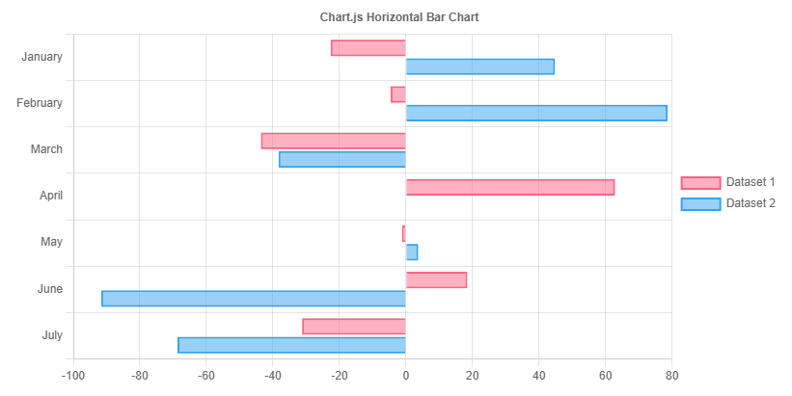
Image from https://www.chartjs.org/docs/latest/samples/bar/horizontal.html

Description: A horizontal bar chart showing the number of days between each game’s Twitch viewership peak and its subsequent Steam concurrent player peak.

Interactive Elements:
- Hover tooltips showing exact lag in days per game and the specific months of each peak

Visualization #3: Scatter Plot
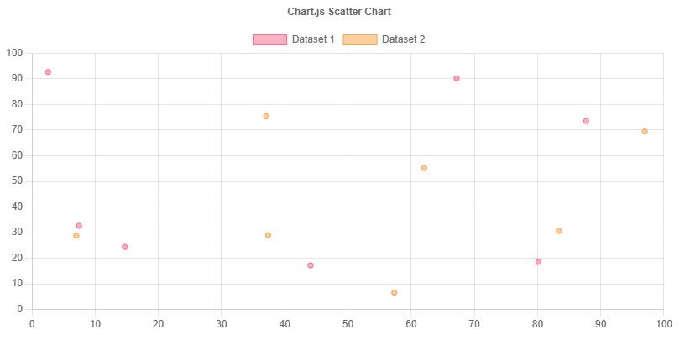
Image from https://www.chartjs.org/docs/latest/samples/other-charts/scatter.html

Description: A scatter plot using all monthly data points across all four games, plotting Twitch average viewers on the x-axis against Steam average players on the y-axis. Each point is color-coded by game. A linear trend line is overlaid to show the overall correlation direction across all games combined.

Interactive Elements:
- Hover tooltips showing game name, month, Twitch viewer count, and Steam player count for each point
- Filter by game case study or view all four simultaneously
- Trend line updates dynamically based on the active game filter
Visualization #4: Bar chart
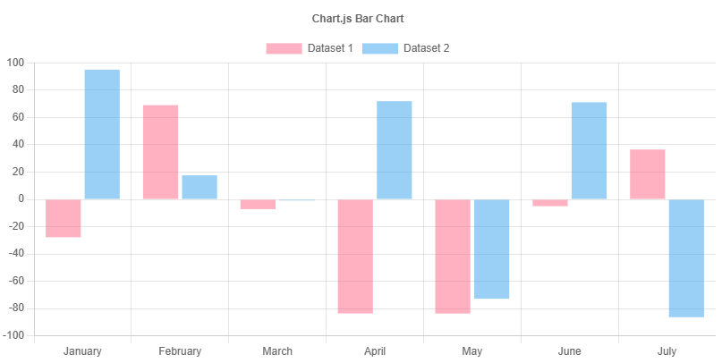
Image from https://www.chartjs.org/docs/latest/samples/bar/vertical.html

Description: A vertical bar chart showing the percentage increase in Steam concurrent players in the 30 days following each game’s Twitch viewership peak. A logarithmic scale is used given the significant variance in growth rates across titles (especially between Among Us and the other games, would make it harder to compare if not normalized).

Interactive Elements:
- Hover tooltips showing exact percentage growth and the raw player count before and after the streamer spike
- Bars are color-coded by game

V. Plans
Ambitious / ideal Plan A:
Tools:
- D3.js – creating a single-page application with all four visualizations described above
- Python (pandas library) – all four case study games with complete Twitch, Steam, and Google Trends data joined into a single master dataset
Delivery:
- GitHub Pages – hosts the application

Fallback Plan B:
Tools:
- Python Plotly – dual axis timeline and lag analysis bar chart will be prioritized
- Python (pandas library) – if all data cleaning is not done in time for all four games, the project will just narrow down to two case studies (Among Us and Lethal Company)
Delivery:
- Vercel – I’m familiar with deploying on it, it’s still free, and it should be simple to send in a website

